

Using Microsoft Message Passing Interface
White Paper

Charlie Russel
Microsoft MVP for Windows Server
Author of Microsoft Windows Server 2003 Administrator’s Companion
(Microsoft Press, 2003)

Published: November 2005
For the latest version of this document, please see http://go.microsoft.com/fwlink/?LinkId=55930

Contents
Introduction 1
What Is MPI? 1
MS-MPI vs. MPICH2 1
MS-MPI Features 2
Programming Features of MS-MPI 2
MPIexec Features 2
Implementing MPI 4
What Protocols and Hardware Are Supported? 4
Topology 5
Security and the MS-MPI Implementation 6
Integration with Active Directory 6
Credential and Process Management 6
Conclusion 7
References 8
Contributors and Acknowledgements
Ryan Waite, Microsoft
Eric Lantz, Microsoft
Kang Su Gatlin, Microsoft
Jason Zions, Microsoft
Peter Larson, Microsoft
Kyril Faenov, Microsoft
Larry Mead, Microsoft
Ryan Rands, Microsoft
Anand Krishnan, Microsoft
Maria Adams, Microsoft
Elsa Rosenberg, Studio B
Carolyn Mader, Studio B
Kathie Werner, Studio B
Heather Locke, Studio B
David Talbott, Studio B

Introduction
Microsoft® Windows® Compute Cluster Server 2003 is a 2-CD package that includes Microsoft® Windows Server™ 2003 operating system, Compute Cluster Edition on the first CD, and Microsoft® Compute Cluster Pack on the second CD. The Compute Cluster Pack is a collection of utilities, interfaces, and management tools that bring personal high-performance computing (HPC) to readily available x64-based computers.

What Is MPI?
The Microsoft ® Message Passing Interface (MPI) software (called MS MPI) is a portable, flexible, vendor- and platform-independent standard for messaging on HPC nodes. MPI is the specification, and MS MPI, MPICH2, and others are the implementations of that standard. MPI2 is an extension of the original MPI specification.
Fundamentally, MPI is the interconnection between nodes on an HPC cluster, tying nodes together. MPI provides a portable and powerful inter-process communication mechanism that simplifies some of the complexities of communication between hundreds or even thousands of processors working in parallel.
MPI consists of two essential parts—an application programming interface (API) that supports more than 160 functions, and a job launcher that allows users to execute jobs.

MS MPI vs. MPICH2
The best known implementation of the MPI specification is the MPICH2 reference implementation created by the Argonne National Laboratory. MPICH2 is an open-source implementation of the MPI2 specification that is widely used on HPC clusters. MS MPI is based on and designed for maximum compatibility with the reference MPICH2 implementation. The exceptions to that compatibility are all on the job launch and job management side of MPICH2—the APIs that independent software vendors (ISVs) use are identical to MPICH2. These exceptions to the MPICH2 implementation were necessary to meet the strict security requirements of CCS.

Note: When using Windows Compute Cluster Server 2003, you are not required to use MS MPI. You can use any MPI stack you choose. The security features that Microsoft has added to MS MPI may not be available in other MPI stacks.

MS MPI Features
MS MPI is a full-featured implementation of the MPI2 specification. It includes more than 160 APIs that ISVs can use for inter-process communication and control, and a job launcher that provides fine-grained control over the execution and parameters of each job.

Programming Features of MS MPI
Although MS MPI includes more than 160 APIs, most programs can be written using about a dozen of those. MS MPI includes bindings that support the C, Fortran77, and Fortran90 programming languages. Microsoft Visual Studio® 2005 includes a remote debugger that works with MS MPI in Visual Studio Professional Edition and Visual Studio Team System. Developers can start their MPI applications on multiple compute nodes from within the Visual Studio environment. Then Visual Studio will automatically connect the processes on each node, so the developer can individually pause and examine program variables on each node.
MPI uses objects called communicators to control which collections of processes can communicate with each other. A communicator is a kind of “party line” of processes that can all receive messages from each other, but that ignore any messages within the communicator unless they are directed to them. Each process has an ID or rank in the communicator. The default communicator includes all processes for the job and is known as MPI_COMM_WORLD. Programmers can create their own communicators to limit communications to a subset of MPI_COMM_WORLD where appropriate.
The MS MPI communications routines also include collective operations. These collective operations allow the programmer to collect and evaluate all the results of a particular operation across all nodes in a communicator in a single call.
MPI supports fine-grained control of communications and buffers across the nodes of the cluster. The standard routines will be appropriate for many actions, but when you need specific buffering, MPI supports it. Communications routines can be blocking or non-blocking, as appropriate.
MPI supports both pre-defined data types and derived data types. The built-in data type primitives are contiguous, but derived data types can be contiguous or noncontiguous.

Mpiexec Features
The normal mechanism for starting jobs in a Windows Compute Cluster Server 2003 cluster is the job submit command, which specifies the mpiexec command parameters for the job. The user can specify the number of processors required and the specific nodes that should be used for a given job. Mpiexec, in turn, gives the user the ability to have full control over how a job is executed on the cluster. A typical command line might be:
job submit /numprocessors:8 /runtime:5:0 mpiexec myapp.exe
This will submit the application myapp.exe to the Job Scheduler, which will assign it to eight processors for a running time not to exceed 5 hours.
Mpiexec supports command-line arguments, environment variables, and command files for execution, giving maximum flexibility in job control to the administrator and user on a CCS cluster. Environment variables can be set for a specific job or globally across the entire cluster.
An important improvement that MS MPI brings to MPICH2 is in how security is managed during execution of MPI jobs. Each job is run with the credentials of the user. Credentials are only present while the job is being executed and are erased when the job completes. Individual processes only have access to a logon token for their process, and do not have access to the job credentials or to the credentials used by other processes.
Developers can also use the Job Scheduler to reserve nodes for a job (including credentials), and then submit the jobs directly from Visual Studio 2005 using mpiexec, greatly simplifying the debugging process of building an application, or, they can create a smaller debugging cluster to use directly from Visual Studio with mpiexec.

Implementing MPI
MPI and MPI2 are specifications. The original MPI specification was formulated and agreed to by the MPI Forum in the early 1990s, and extended in 1996 by the same group of approximately 40 organizations to create the MPI2 specification. Today the MPI specifications are the de facto message-passing standards across practically all HPC platforms.
Programs written to MPI are portable across platforms and across various implementations of MPI without the need to rewrite source code. Although originally targeted at distributed systems, MPI implementations now support shared-memory systems as well.

What Protocols and Hardware Are Supported?
CCS includes MS MPI as part of the Microsoft® Compute Cluster Pack. MS MPI uses the Microsoft WinSock Direct protocol for maximum compatibility and CPU efficiency. MS MPI can use any Ethernet interconnect that is supported by Windows Server 2003 operating systems as well as such low-latency and high-bandwidth interconnects as InfiniBand or Myrinet. Windows Compute Cluster Server 2003 supports the use of any network interconnect that has a Winsock Direct provider. Gigabit Ethernet provides a high-speed and cost-effective interconnect fabric, while InfiniBand and Myrinet are ideal for latency-sensitive and high-bandwidth applications.
The WinSock Direct protocol bypasses the TCP/IP stack, using Remote Direct Memory Access (RDMA) on supported hardware to improve performance and reduce CPU overhead. Figure 1 shows how MPI works with WinSock Direct drivers to bypass the TCP/IP stack where drivers are available.
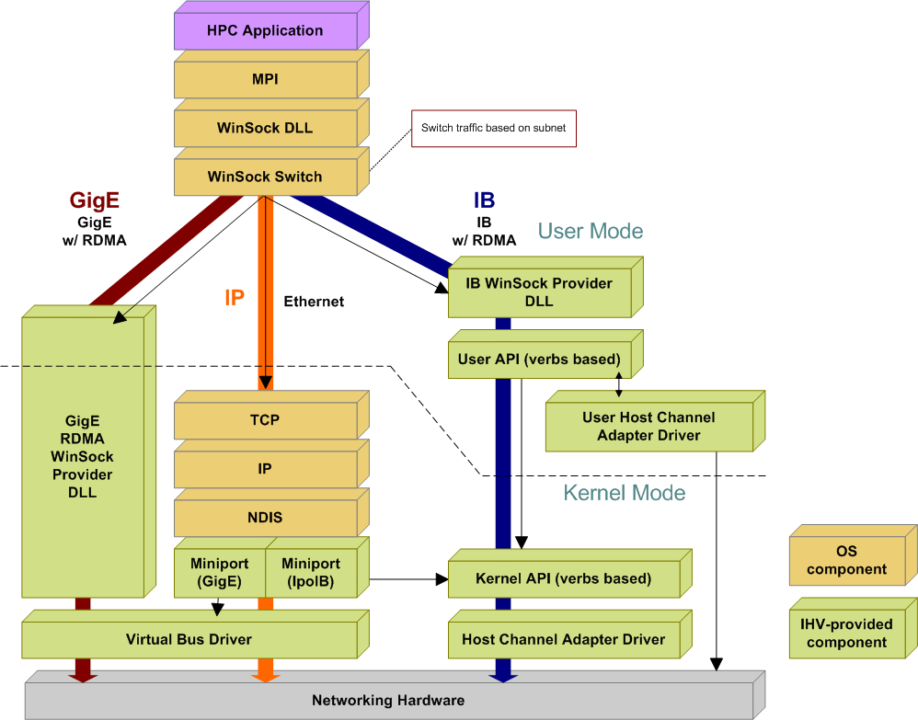
Figure 1. WinSock Direct topology

Topology
Windows Compute Cluster Server 2003 supports a variety of network topologies, including those with a dedicated MPI interface, those that use a private network for both cluster communications and MPI, and even supports a topology that uses a single network interface on each node that shares a public network for all communications. These five topologies are supported:
- Three NICs on each node. One NIC is connected to the public (corporate) network; one to a private dedicated cluster management network; and one to a high-speed dedicated MPI network.
- Three NICs on the head node and two on each of the cluster nodes. The head node uses Internet Connection Sharing (ICS) to provide network address translation (NAT) services between the compute nodes and the public network, with each compute node having a connection to the private network and a connection to a high-speed protocol such as MPI.
- Two NICs on each node. One NIC is connected to the public (corporate) network, and one is connected to the private dedicated cluster network.
- Two NICs on the head node and one on each of the compute nodes. The head node provides NAT between the compute nodes and the public network.
- A single NIC on each node with all network traffic sharing the public network. In this limited networking scenario, Remote Installation Services (RIS) deployment of compute nodes is not supported, and each compute node must be manually installed and activated.
CCS is based on Windows Server 2003 and is designed to integrate seamlessly with other Microsoft server products. For example, Microsoft Operations Manager can be used to monitor CCS, or applications can integrate with Exchange Server to mail job status to the job owner.
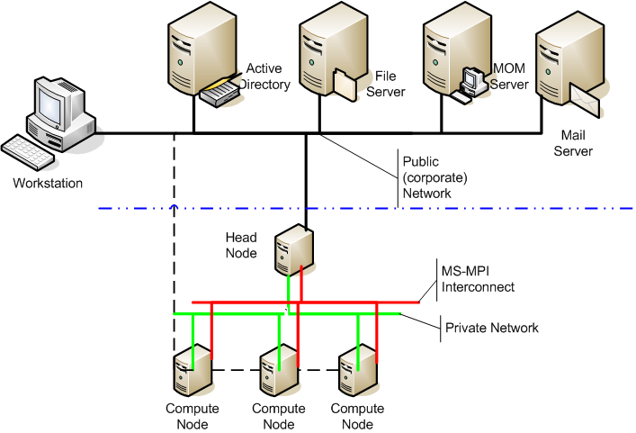
Figure 2. Typical CCS network topology
In a debugging environment, the developer’s Visual Studio workstation needs direct access to the compute nodes to be able to do remote debugging.

Security and the MS MPI Implementation
The most significant difference between MS MPI and the reference MPICH2 implementation is found in the way security is handled. MS MPI integrates with Microsoft® Active Directory® directory service to simplify running with user credentials instead of using the root account to run jobs.

Integration with Active Directory
CCS is integrated with and dependent on Active Directory to provide security credentials for users and jobs on the cluster. Before the Compute Cluster Pack can be installed on the head node and the cluster actually created, the head node must be joined to an Active Directory domain or be promoted to be a Domain Controller for its own domain.
Active Directory accounts are used for all job creation and execution on the cluster. All jobs are executed using the credentials of the user submitting the job.

Credential and Process Management
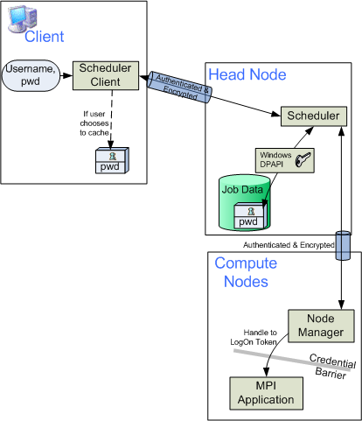
When an MPI job is submitted, the credentials of the user submitting the job are used for that job. At no time are passwords or credentials passed in clear text across the network. All credentials are passed using only authenticated and encrypted channels, as shown in Figure 3. Credentials are stored with the job data on the head node, and deleted when the job completes. At the user’s discretion, the credentials can also be cached at the individual client computer in order to streamline job submission, but when this option is chosen, they are encrypted with a key known only to the head node. While a job is being computed, the credentials are used to create a logon token and then erased. Only the token is available to the processes being run, further isolating credentials from other processes on the compute nodes.
These processes that are running on the compute nodes are run as a single Windows job object, enabling the head node to keep track of job objects and cleanup any processes when the job completes or is cancelled.

Figure 3. Credential management of MPI jobs

Conclusion
MPI and MPI2 are widely accepted specifications for managing messaging in high performance clusters. Among the most widely accepted implementation of MPI is the open-source Argonne National Laboratory’s MPICH2 reference implementation. Microsoft Windows Compute Cluster Server 2003 includes the Microsoft implementation of MPI (MS MPI). MS MPI is based on MPICH2 and is highly compatible with it. At the API level, it is identical to all 160+ APIs defined by MPICH2, while adding enhanced security and process management capabilities for enterprise environments. MS MPI uses WinSock Direct drivers to provide high-performance MPI network support for Gigabit Ethernet and InfiniBand adapters, and supports all adapters that have a WinSock Direct provider.

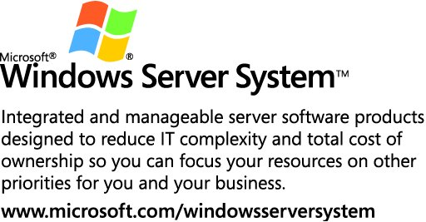

Legalese
This is a preliminary document and may be changed substantially prior to final commercial release of the software described herein.
The information contained in this document represents the current view of Microsoft Corporation on the issues discussed as of the date of publication. Because Microsoft must respond to changing market conditions, it should not be interpreted to be a commitment on the part of Microsoft, and Microsoft cannot guarantee the accuracy of any information presented after the date of publication.
This white paper is for informational purposes only. MICROSOFT MAKES NO WARRANTIES, EXPRESS OR IMPLIED, IN THIS
DOCUMENT.
Complying with all applicable copyright laws is the responsibility of the user. Without limiting the rights under copyright, no part of this document may be reproduced, stored in, or introduced into a retrieval system, or transmitted in any form or by any means (electronic, mechanical, photocopying, recording, or otherwise), or for any purpose, without the express written permission of Microsoft Corporation.
Microsoft may have patents, patent applications, trademarks, copyrights, or other intellectual property rights covering subject matter in this document. Except as expressly provided in any written license agreement from Microsoft, the furnishing of this document does not give you any license to these patents, trademarks, copyrights, or other intellectual property.
© 2005 Microsoft Corporation. All rights reserved.
Microsoft, Active Directory, Visual Studio, and Windows Server are either registered trademarks or trademarks of Microsoft Corporation in the United States and/or other countries.
All other trademarks are property of their respective owners.
1105

References
MPICH2 Home Page
(http://go.microsoft.com/fwlink/?LinkId=55115)
MPI tutorial at the Lawrence Livermore National Lab
(http://go.microsoft.com/fwlink/?LinkId=56096)
Deploying & Managing Compute Cluster Server 2003
(http://go.microsoft.com/fwlink/?LinkId=56096)
Using the Compute Cluster Server 2003 Job Scheduler
(http://go.microsoft.com/fwlink/?LinkId=55929)
Migrating Parallel Applications
(http://go.microsoft.com/fwlink/?LinkId=55931)
Debugging Parallel Applications Using Visual Studio 2005
(http://go.microsoft.com/fwlink/?LinkId=55932)

